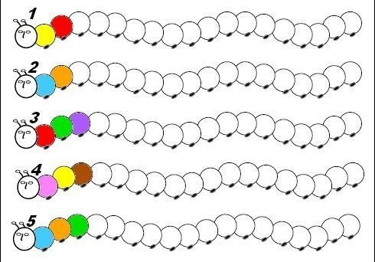

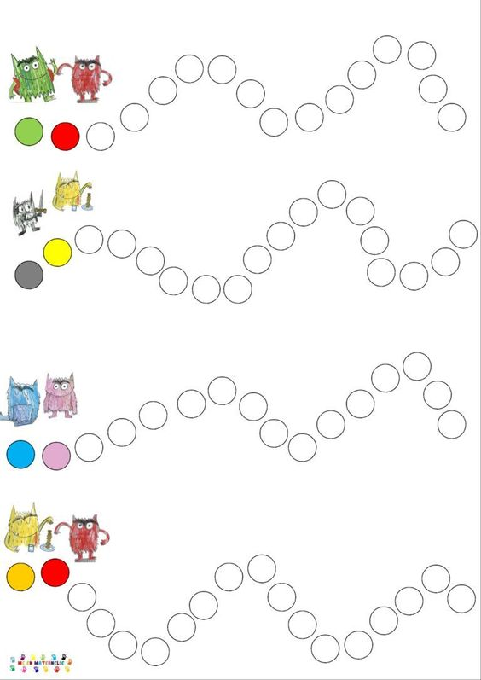

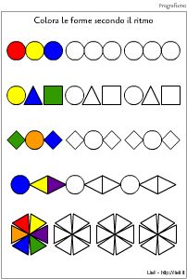

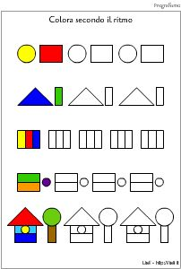

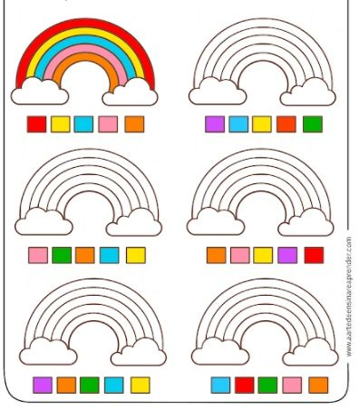

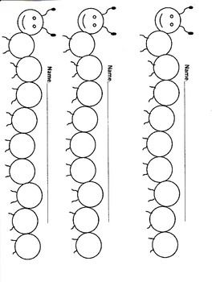ALTERNA I COLORI:



GIALLO E ROSSO

_______________________________________________________________________________________



GIALLO, ROSSO E VERDE

______________________________________________________________________________________





BLU, ARANCIONE, MARRONE